**Game Design Document**

1. Write the title of your project.

Flappy Bird.

1. What is the goal of the game?

Make the flappy bird pass through the obstacles and travel as far as possible.

1. Write a brief story of your game.

The flappy bird is travelling south during spring season and she has to pass through many obstacles before she can reach there. These obstacles are mainly the cities, its factories and chimneys. Flappy bird should weave through them and fly along her path to destination.

1. Which are the playing characters of this game?

* Playing characters are the ones which respond to the user based on the input from the user
* Cars, monkeys, dinosaurs, wizards etc., are the playing characters in the game.

|  |  |  |
| --- | --- | --- |
| Number | Character Name | What can this character do? |
| 1 | Flappy Bird | Fly |

1. Which are the Non-Playing Characters of this game?

* Non-Playing characters are the ones which don't have an action or a behavior when the user interacts with the game.
* Hurdles, stones, bananas, coins, etc. are non-playing characters in the game.

|  |  |  |
| --- | --- | --- |
| Number | Character Name | What can this character do? |
| 1 | Pipes | Obstacles in game |
| 2 | City with Buildings | Game Background, moves infinitely |
| 3 | Ground | Moves infinitely |

1. Draw your imagination of this game. What does this game look like?

* Draw the game either on your computer or on paper,
* Add images of scenes of the game to show each of the playing and non-playing characters at least once.

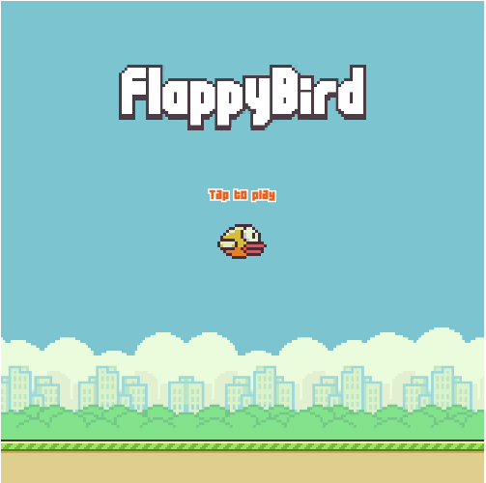 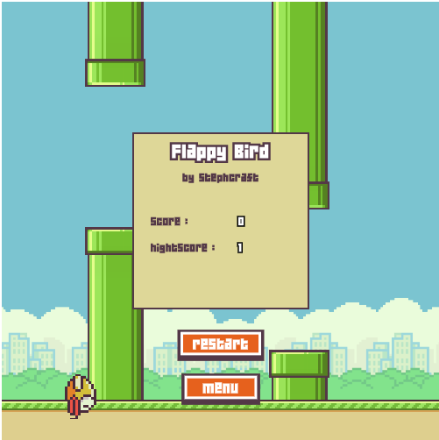

1. How do you plan to make your game engaging?

The game adaptivity is ensured by having menu at the beginning of game, restart option for player to try again, showing scores, highest score made by player, sound, increase speed of the game at regular intervals, and by displaying message to user about how to paly the game.